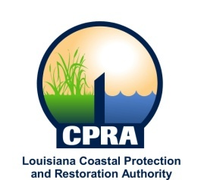

2015 Public Meetings

Jerome Zeringue, Chairman of the Coastal Protection and Restoration Authority, and Executive Assistant to Governor Bobby Jindal for Coastal Activities has announced the public meetings schedule for the Coastal Protection and Restoration Authority and the Governor’s Advisory Commission on Coastal Protection, Restoration and Conservation. Details on each meeting will be sent out at a later date. The dates and locations of these meetings are subject to change

CPRA
January 21, 2015
Lake Charles, LA

February 11, 2015
Baton Rouge, LA

March 25, 2015
Houma, LA

April 15, 2015
Baton Rouge, LA

May 20, 2015
Baton Rouge, LA

June 17, 2015
Baton Rouge, LA

July 15, 2015
Baton Rouge, LA

August 19, 2015
Baton Rouge, LA

September 16, 2015
Morgan City, LA

October 21, 2015
Baton Rouge, LA

November 18, 2015
Baton Rouge, LA

Governor’s Advisory Commission
February 26, 2015
Baton Rouge

April 1, 2015
Baton Rouge, LA

June 3, 2015
Lake Charles, LA

August 5, 2015
Abbeeville, LA

October 8, 2015
Port Fourchon, LA

December 2, 2015
New Orleans, LA

